**Genii Analytics | Calibration | AQA**

V1. December 2020

Contents

Scope 2

Process 2

Creating A Gauge 3

Views 5

Calibration 5

Gauge 7

Interactive reports 8

Gauge Performance Metric 9

Assessor Performance Metric 11

Notes: 11

# Scope

This feature is to assist the quality manager.

Allowing them to ensure that all their staff have the same understanding of varies output metrics.

Identifying those who are not aligned for retraining.

Only the Quality Manager (and higher) profile will be able to view all reports (interactive, csv and pdf) associated with gauges and calibrations.

Calibrations can be done on live campaigns without affecting agent results and reports can now be generated focussing on the assessor’s productivity and not the agents.

It should be noted that the variance will be calculated using the answers on the Question Form and not the Call Details form.

It should also be noted than only the output metric selections (Yes, No or N/A) are used to create the variance. Any variation below level 2 is not included in the calculation.

# Process

1. Create a gauge (standard) assessment and allocate a target.
   1. This needs to be done before any assessors does a calibration on the same connection id.
   2. If an assessor has already done an assessment or calibration on a connection id, you will not be able to create /use the connection id to create a gauge.

(There is an issue logged to have calibration or gauge done in any order - https://github.com/GeniiDevCore/DevWebApps_IA_core/issues/1984)

1. Have the assessors do calibration calls using the same connection id.
   1. Each assessor can only do one calibration per gauge.

# Creating A Gauge

As Quality Manager (QM) you will be able to use a live campaign to do calibration on without affecting the agent’s scores.

When you access the capture form, you will select Gauge from the call reason list.

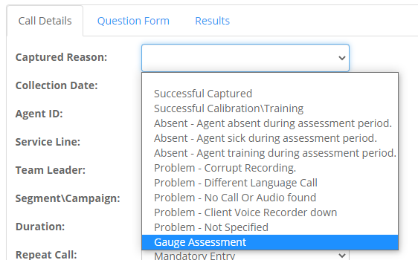

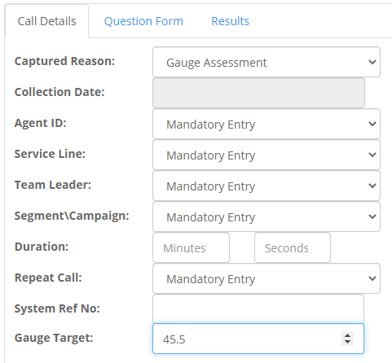

You will see that at the bottom left-hand side another input box will appear.

This is your target box; you will have to set a target for each gauge and this target will align the colours on your interactive reports.

Your target must consist of whole numbers and can accept one decimal point (75; 75.5).

Once you have validated and submitted your gauge, you can the pass the connection id to your assessors so that they can assess the same call on the same campaign.

They will use the same connection id and select Successful Calibration\Training from the Captured Reason drop down.

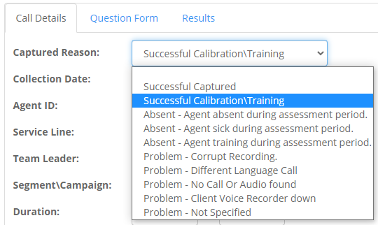

# Views

There are two new views available to you as the QM on the Overview page.

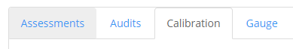

## Calibration

You may have noticed that you no longer see calibration calls on the Assessment tab on the Overview page.

Calibrations have been moved to a tab on their own. This means that Audits on calibration calls can only be done by you as the QM.

Here you will see calibrations done against a gauge as well as those without a gauge.

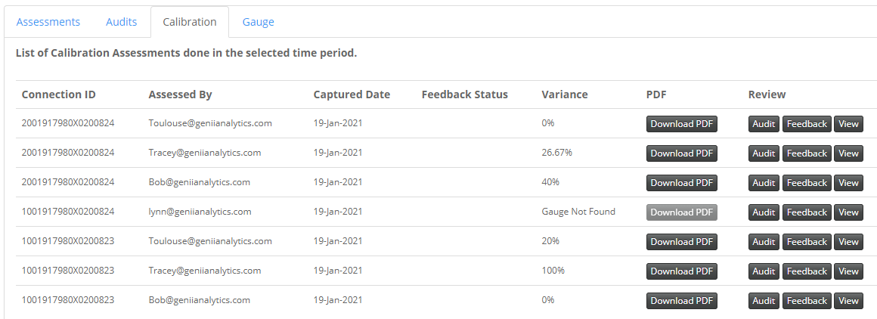

Those with a gauge will display a variance score and will have a pdf to download whereas the other will not.

Here individual connection ids with the associated assessor will display.

The variance score should be as low as possible.

From this page you can Audit, give Feedback and View the calibration.

Below is an example of the pdf download.

Here you have a view of each output metric and its’ score as well as an overall section accuracy score.

There is also a Review link that will take you to the feedback page, like the one used for agent feedback.

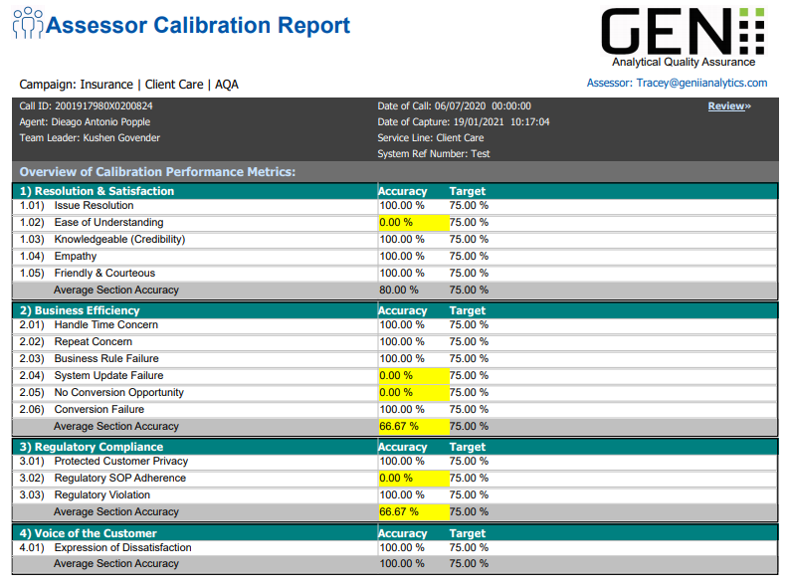

Review page

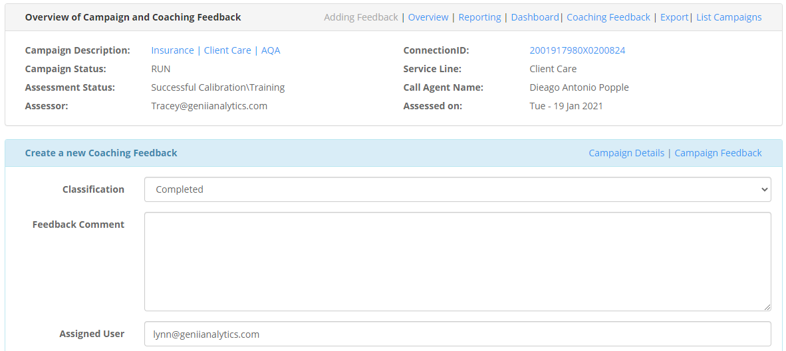

## Gauge

The Gauge tab is a summary tab.

This tab will give the number of gauges created.

The number of calibrations done against each gauge as well as the average variance to target.

There are also place holders for other future reports.



You may notice that you can audit the gauge, note that if you do change the output metric answers on the gauge it will realign the scores on all the link calibrations.

# Interactive reports

You will find the following reports on the Dashboard menu option.

The dynamic filter here will only apply to the gauge and not the answers given by the assessors.

Whereas the Views showed the variance to gauge, the Interactive reports will show you the accuracies.

Each table can be exported to .csv.

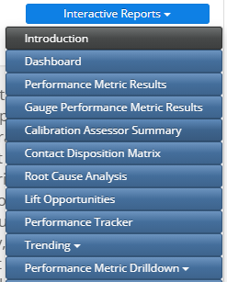

## Gauge Performance Metric

This report will give you the average Performance Metric Results per Gauge.

As you can see from the screen shot you will be able to see if your assessors are improving from gauge to gauge.

The latest gauge will be first and so on until the average score column.

You will note that 66.67% have different colours, this is due to the gauge target you set when completing the gauge.

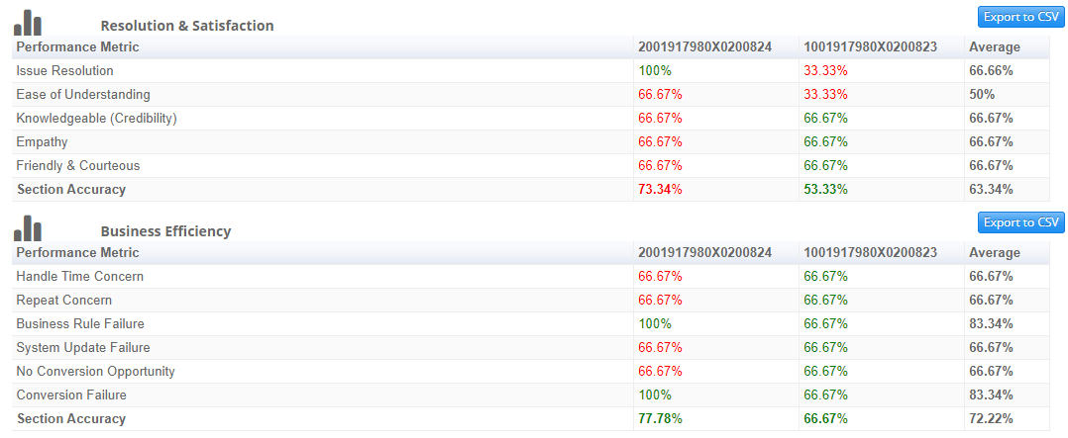

If you have more than 3 gauges, you can use the Sessions filter on the Gauge filter to select the gauges you wish to compare.

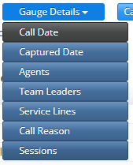

You can also select specific assessors if you want to check for individual improvement across gauges.



In the example below, Bob’s scores have gotten worse since the initial gauge.

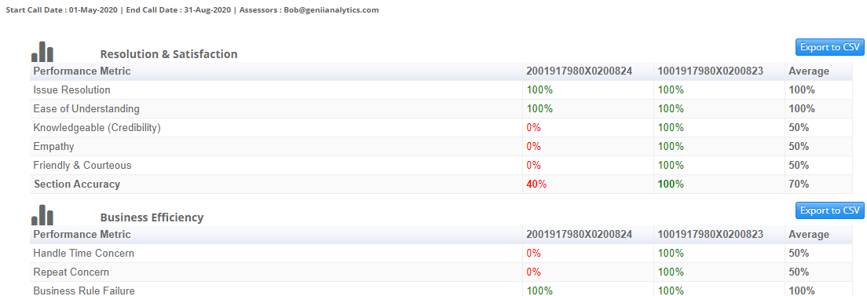

## Assessor Performance Metric

This report will allow you to compare peers.

You can do across all gauges or select a specific gauge/session using the filter.

You can also specify which assessors you wish to compare using the filter.

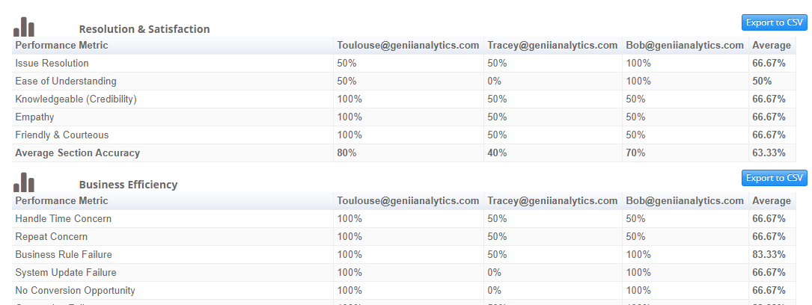

# Notes:

This is the initial rollout for this function.

New features will be added as dictated by necessity.